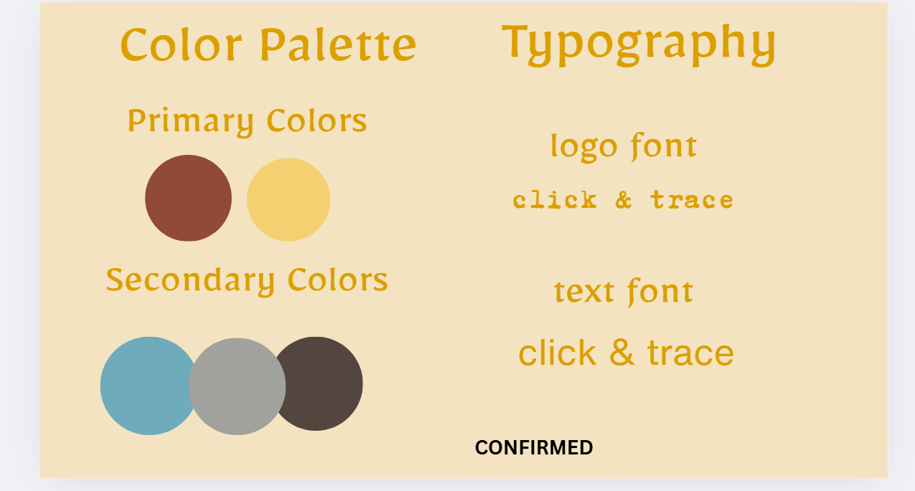

Font:
29LT Makina (logo & headlines)
Helvetica Now (body paragraphs)

1- Heliopolis: The Ancient City of the Sun
Located in modern-day Ain Shams and Al-Matareya, Heliopolis (ancient Iunu) was one of Egypt’s oldest and most vital religious capitals. As the primary center for the worship of the sun god Ra, it birthed the "Ennead" creation myth, which fundamentally shaped ancient Egyptian theology. Beyond its spiritual role, the city was a prestigious hub of knowledge where priests developed the solar calendar. Today, while much of the city lies beneath Cairo’s vibrant neighborhoods, the Obelisk of Senusret I still stands in its original place. Recent discoveries, including monumental statues of Ramses II, continue to reveal the enduring legacy of this "City of the Sun."
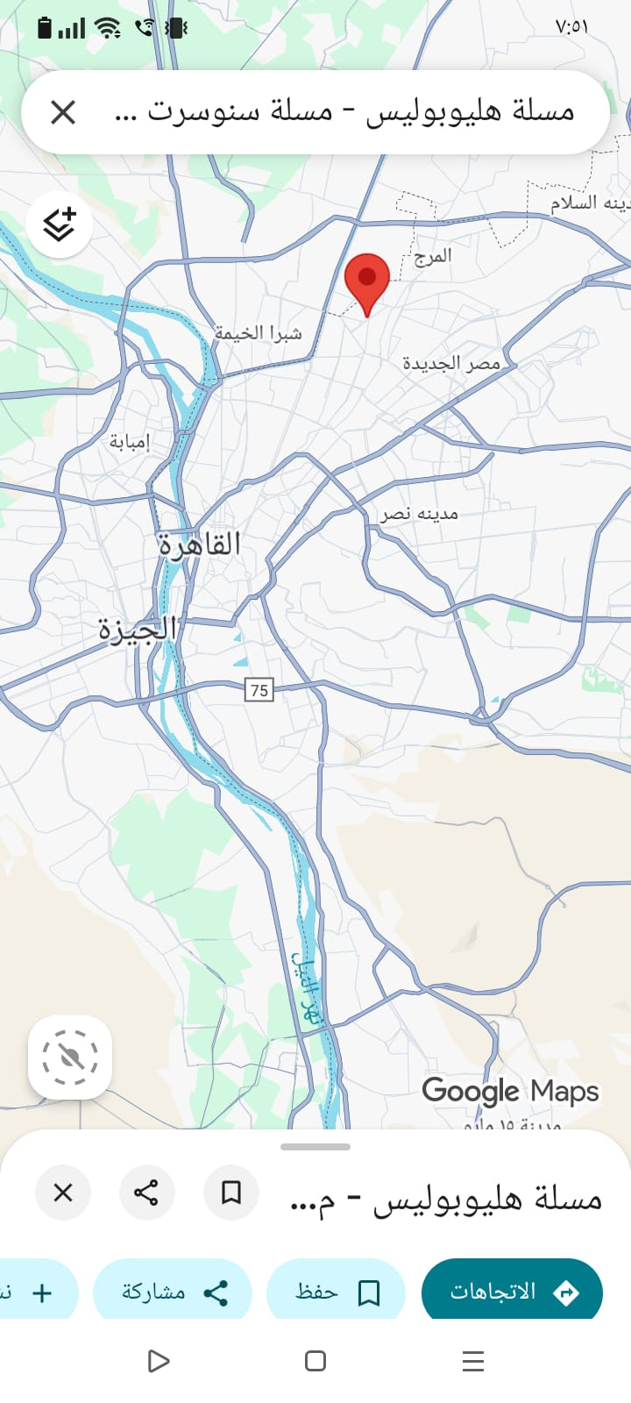

2- Memphis (Mit Rahina) – The First Capital of Unified Egypt
Situated near Saqqara, about 19 km south of Cairo, Memphis (ancient Men-nefer) was founded around 3200 BC by King Narmer as the first capital of a unified Egypt. During the Old Kingdom, it served as the nation's political, administrative, and cultural heart. As the center for the worship of the god Ptah, the patron of craftsmen, the city became a major hub for art and industry. Today, its Open-Air Museum showcases remarkable artifacts, including the colossal limestone statue of Ramesses II and the Alabaster Sphinx. Despite modern environmental challenges, Memphis remains a cornerstone of human heritage, representing the dawn of the Egyptian state.
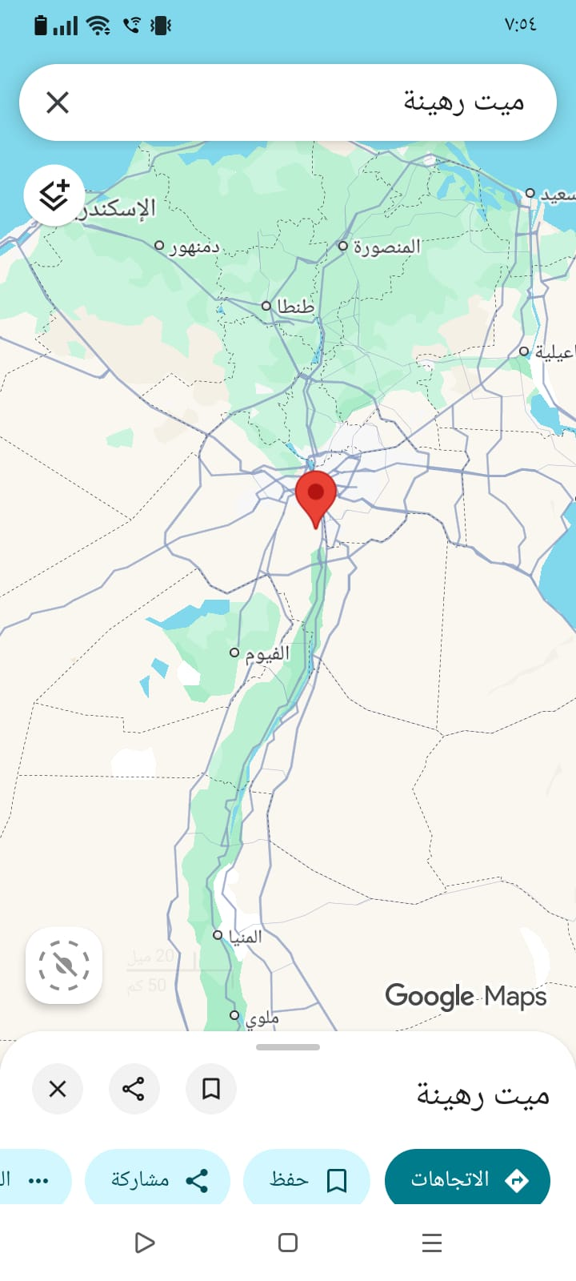
3- Tanis (San Al-Hagar) – The "Thebes" of the North
Located in the Sharqia Governorate, Tanis (ancient Djanet) served as the majestic capital of Egypt during the 21st and 22nd Dynasties. Often referred to as the "Thebes of the Lower Egypt," it was a major political and religious powerhouse dedicated to the god Amun. The city gained worldwide fame for its Royal Tombs, particularly that of King Psusennes I, whose golden treasures are ranked among the most spectacular finds in archaeological history, rivaling those of Tutankhamun. Today, Tanis offers an authentic, off-the-beaten-path experience where visitors can wander among colossal statues, fallen obelisks, and ancient temple blocks that whisper stories of a grand era.
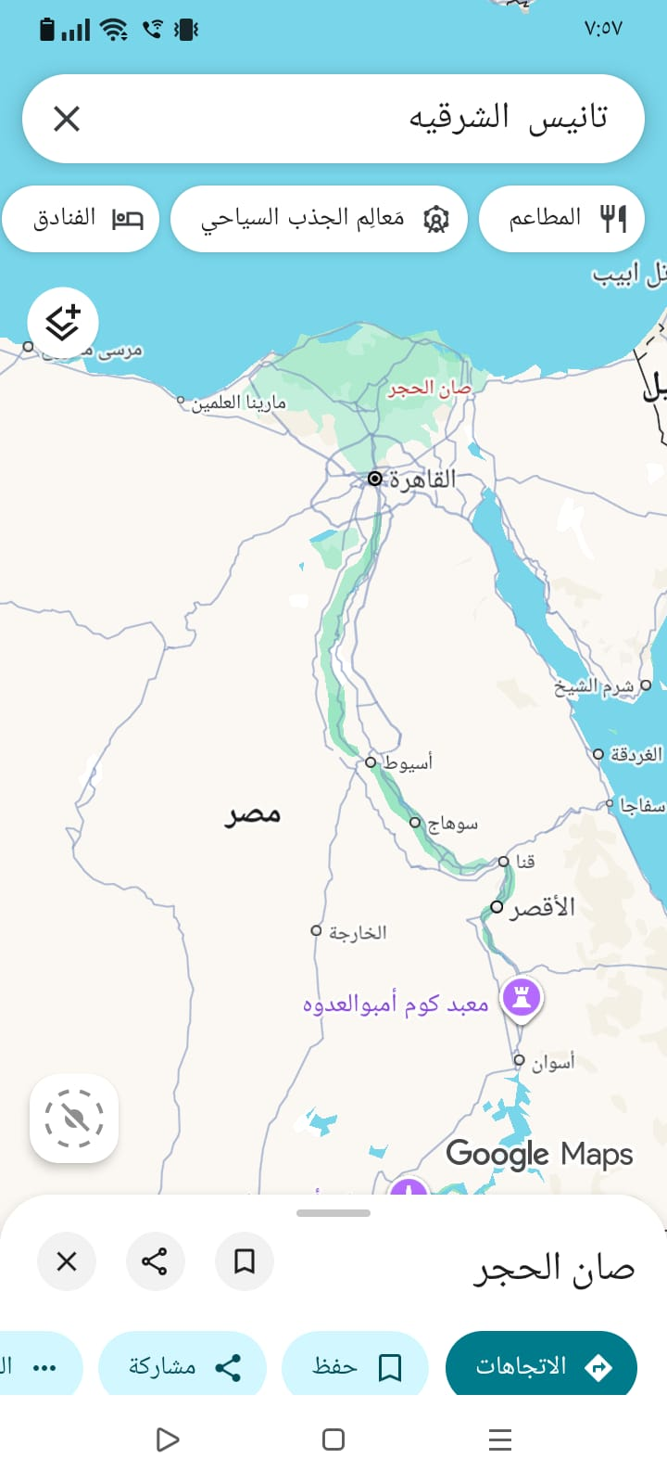
4- Qantir (Pi-Ramesses) – The Imperial Residence of the Ramessides
Located in the Sharqia Governorate, the modern village of Qantir sits atop the remains of Pi-Ramesses, the magnificent capital founded by Pharaoh Ramesses II. During the 13th century BC, this city was the political, military, and industrial powerhouse of the New Kingdom. Its strategic location near the northeastern border made it a vital hub for defense and trade with Asia. Archaeological finds highlight a highly organized metropolis, featuring royal palaces, massive residential districts, and advanced workshops for bronze and glass production. Qantir remains a key site for understanding the peak of royal power and the sophisticated daily life of ancient Egypt's imperial age.
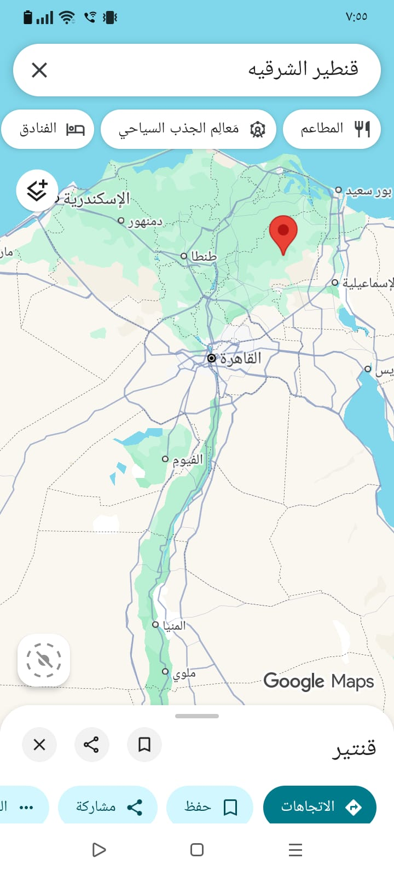
5- Shidet (Fayoum):
Shidet, now Fayoum City, was an important ancient Egyptian city and the capital of the Fayoum region. Known as Shedet in Pharaonic times and later as Arsinoe by the Greeks, it was a major religious and administrative center, closely linked to the worship of the crocodile god Sobek. Archaeological remains in modern Fayoum, including temples, houses, coins, pottery, and papyri, reveal daily life and the city’s evolution. During the Roman period, some temples were rebuilt or relocated, showing continuity and transformation in the region’s religious and cultural practices, such as the Sobek temple at Kom Oshim.
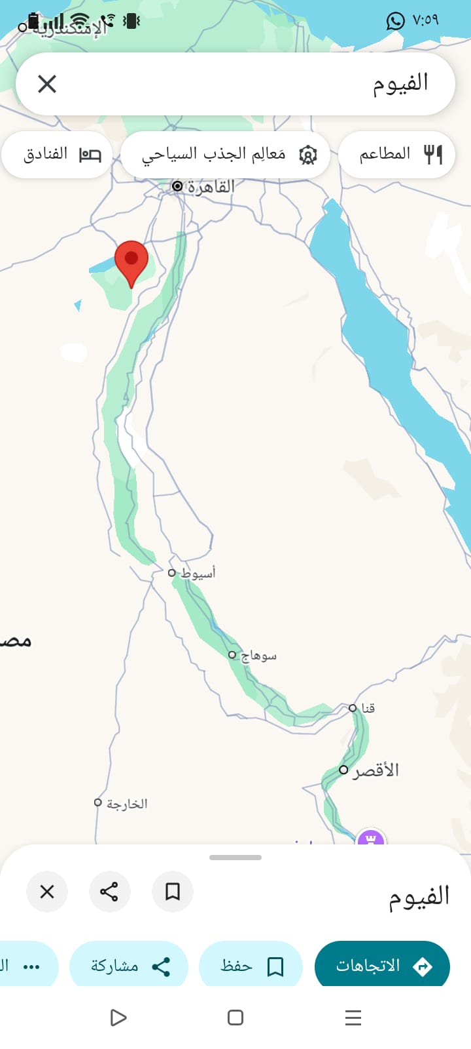
6- Tell el-Amarna:
located in Egypt’s Minya Governorate on the eastern bank of the Nile, was founded in the 14th century BC by King Akhenaten as the city of Akhetaten, the new capital dedicated to his monotheistic worship of Aten. After Akhenaten’s death, the city was abandoned and eventually became known as Tell el-Amarna. The site is significant for its well-preserved tombs, palace remains, and temples, offering a rare and detailed view of daily life, art, architecture, and religious practices during this brief but transformative period in ancient Egyptian history.
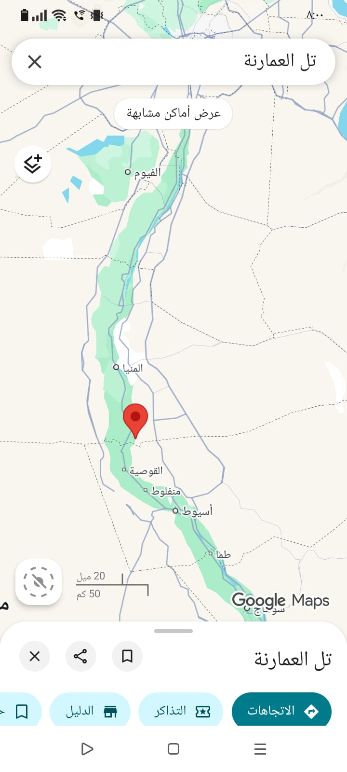
7- Akhmim is a city in Sohag Governorate on the east bank of the Nile. In ancient Egypt, it was the capital of the Ninth Nome of Upper Egypt, known as Khent-Min, and later called Panopolis during the Greek period. It was a major religious center devoted to Min, the god of fertility, and hosted important temples, including one built by King Ramesses. Archaeological finds, such as the large statue of Princess Merit-Amun, highlight its rich history. Akhmim was also an industrial hub for textiles and silk, earning the nickname “the Manchester of Prehistory.” The city combined religion, art, and industry.
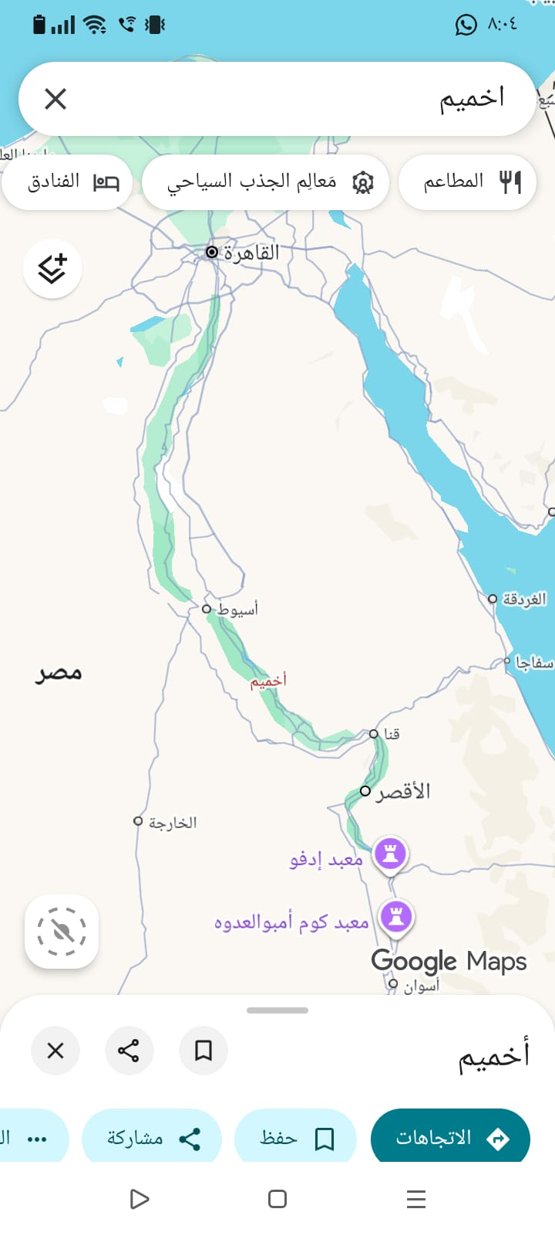
8- Abydos: is an ancient city in Upper Egypt, in the Sohag region, known for its temples, cemeteries, and royal monuments spanning thousands of years. It was one of Egypt’s earliest sacred cities, serving as a burial site for early kings of the First and Second Dynasties. Over time, Abydos became an important administrative and religious center. It was especially significant as a cult center for Osiris, attracting pilgrims and hosting rituals. Key archaeological finds, including royal funerary complexes and the Temple of Seti I with the Abydos King List, provide insights into early Egyptian religion, kingship, and state formation. Excavations continue to uncover more about ancient Egyptian culture and daily life.
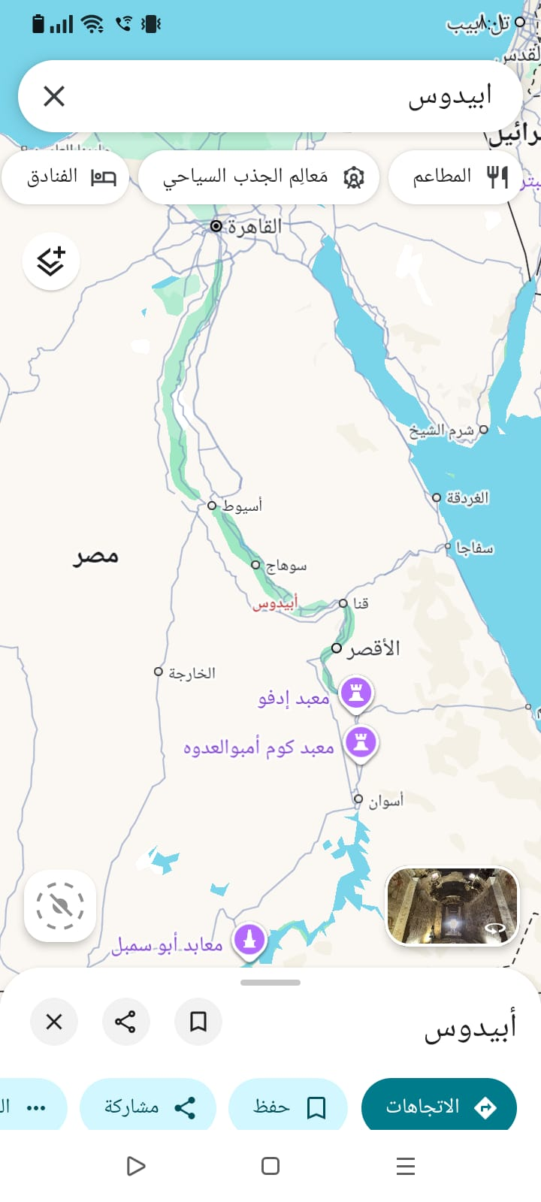
9- Thebes (Luxor): Located in Upper Egypt along the Nile, Thebes was divided into the East Bank (city of the living) and the West Bank (necropolis). Known in ancient times as Waset (“City of the Scepter”) and niw.t-jmn (“City of Amun”), it became Egypt’s main political and religious capital during the New Kingdom, especially under Ahmose I and Amenhotep III. Thebes was a major center for worshiping Amun-Re, hosting Karnak and Luxor Temples, the Valley of the Kings, and the Valley of the Queens. Around 1500 BCE, it was one of the largest and wealthiest cities, serving as a key trade hub. Today, its ruins are a UNESCO World Heritage Site. Thebes, along with other ancient Egyptian cities like Memphis, Tanis, and Abydos, illustrates how Egypt’s political, religious, and economic centers were interconnected along the Nile, reflecting shifts in power and belief over millennia.
